Step 1->Open Visual Studio

Step 2-> Create a new Project

Step 3->Select ASP.NET Core Web API

Step 4->Give project name

Step 5->Open Tools->NuGet Package Manager->Manage NuGet Packages For Solution

Step 6->Download the following packages

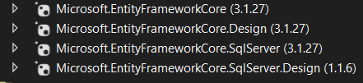

Step 7->Open Solution Explorer

Step 8->Add connectionstring in appsetting.json

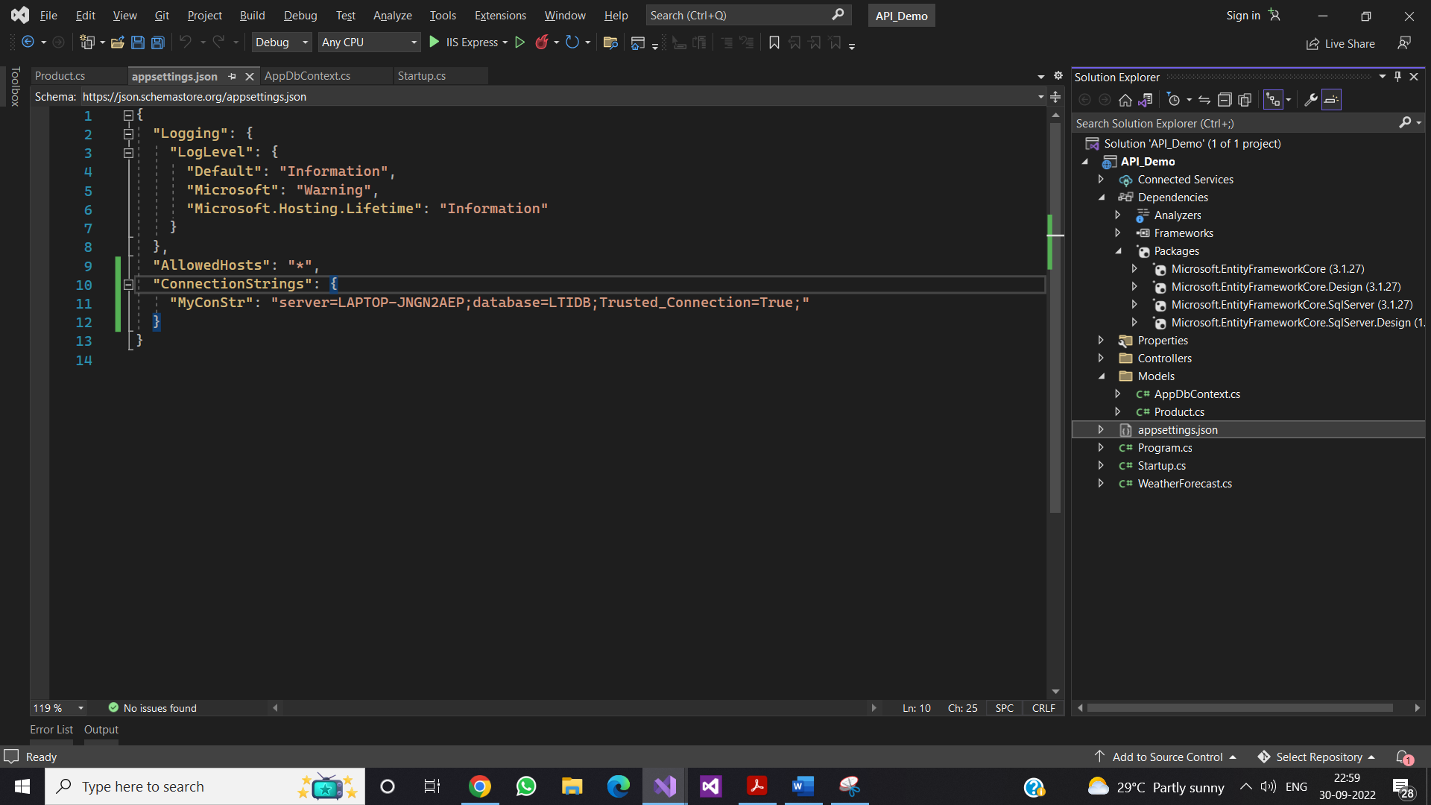

Step 9->Create Models folder

Step 10-> create classes according to the table name and add those column names as properties

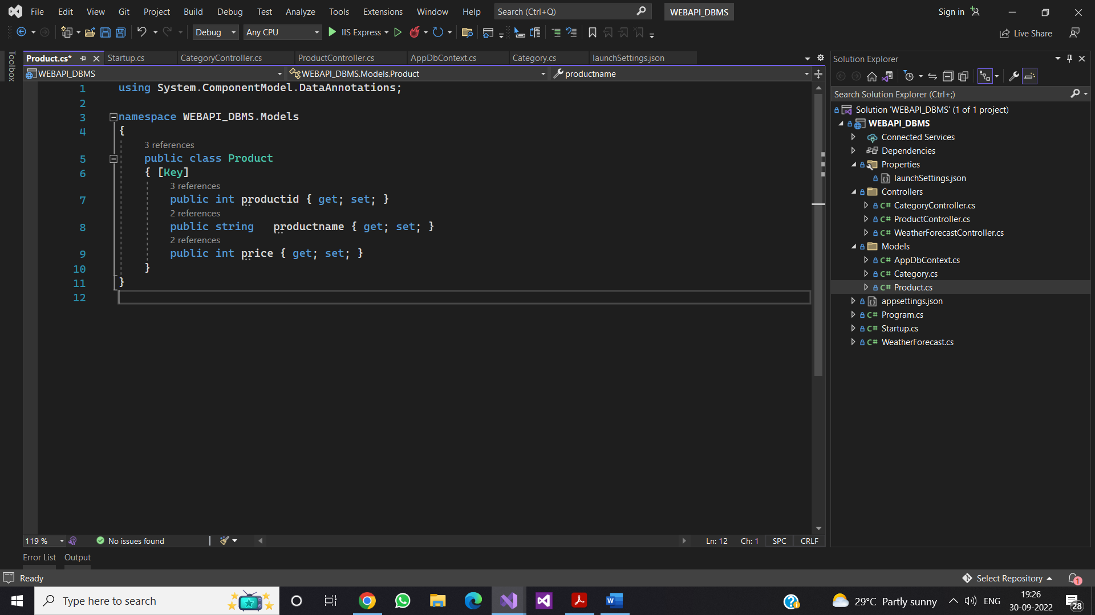

Step 11->add AppDbContext class

Step 12->add tables as DbSet properties

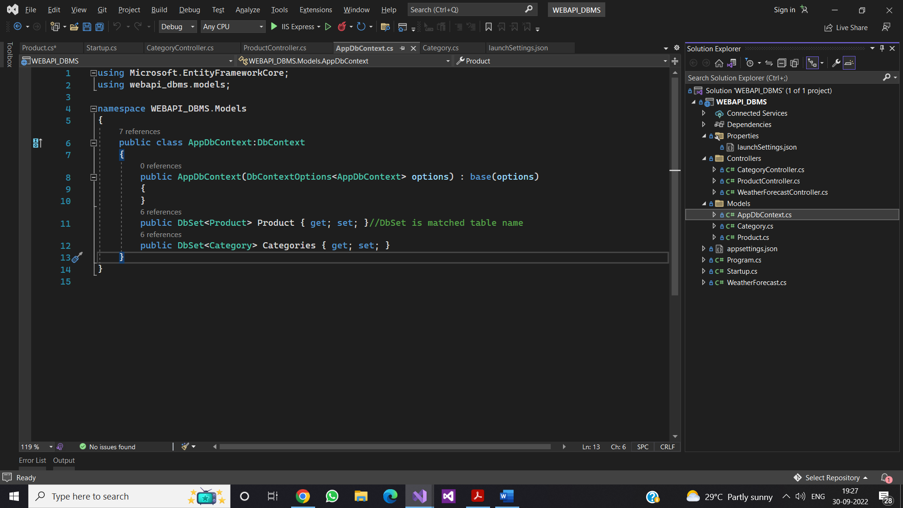

Step 14->Create controller

using API_Demo.Models;

using Microsoft.AspNetCore.Http;

using Microsoft.AspNetCore.Mvc;

using System.Linq;

namespace API_Demo.Controllers

{

[Route("api/[controller]")]

[ApiController]

public class ProductController : ControllerBase

{

private AppDbContext _context;

public ProductController(AppDbContext context)

{

_context = context;

}

public ActionResult get()

{

var data = _context.Product.ToList();

return Ok(data);

}

}

}